**Experiment – 2.2**

**Student Name: Yash Gupta           UID: 20BCS5009**

**Branch: CSE           Section: 709-A**

**Subject Name: Computer Networks Lab**

**Subject Code: 20CSP-257**

**Aim:-**

**Create different network topologies like Star, Bus and Mesh Topology with the help of packet tracer and show the output.**

**Star:-**

**Star topology is a network topology in which each network component is physically connected to a central node such as a router, hub or switch.**

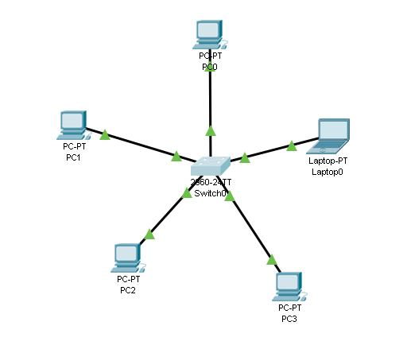

**BUS:-**

**In a bus topology, all nodes in the network are connected directly to a central cable that runs up and down the network - this cable is known as the backbone. Data is sent up and down the backbone until it reaches the correct node.**

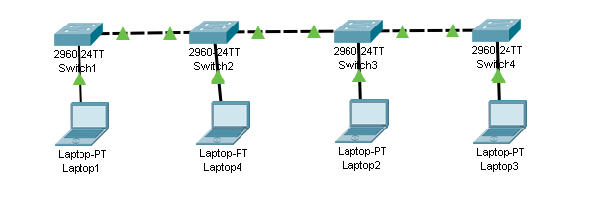

**Ring:-**

**A ring topology is a network configuration where device connections create a circular data path. Each networked device is connected to two others, like points on a circle. Together, devices in a ring topology are referred to as a ring network.**

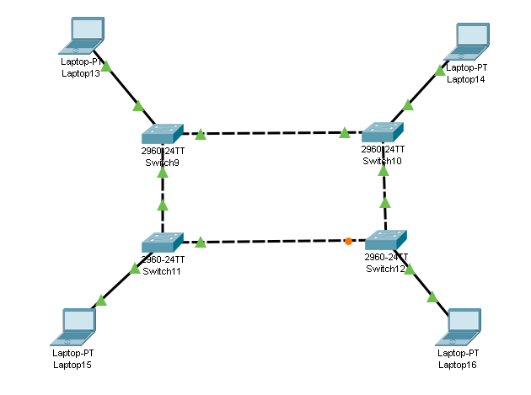

**Mesh:-**

**A mesh topology is a network setup where each computer and network device is interconnected with one another. This topology setup allows for most transmissions to be distributed even if one of the connections goes down. It is a topology commonly used for wireless networks.**

